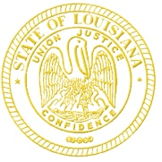 | State of Louisiana  Office of the Governor  DRUG POlicy
John Bel Edwards  Governor |  | Kristy Miller  Director
PUBLIC MEETING NOTICE

The Office of Drug Policy announces the following meeting to which all members of the public are invited to attend.

Subject: Governor’s DWI Task Force

Meeting Date: Wednesday, August 24, 2022

Meeting Time: 10:00 am – 12:00 pm

Meeting Location: 4th Floor Press Room, LA State Capitol Building

Contact: Kristy Miller, 225-235-3073 or Kristy.Miller@la.gov

************************************************
AGENDA

Call to Order

Welcome and Introductions

Old Business
- Recent Victories

- Discuss and Approve: Minutes from May 2022 meeting

- Presentation and Vote: A Resolution to Support Implementation of Oral Fluids Drug Testing Practices in Louisiana

New Business
- Recommendation Workgroup Updates

Other Business
- Office of Drug Policy update
- Member agency updates

Comments from stakeholders and members of the public

Upcoming Meetings of Other Office of Drug Policy boards

Adjournment

